**Name : Antuley Aman Siraj.**

**Roll No. : 23CO25.**

**Class : SE-CO**

**Batch : 01**

**Experiment - 06**

**AIM:** Perform Simple queries, string manipulation operations and aggregate functions.

***1. SIMPLE SQL QUERIES***

These are basic queries to **retrieve data** from a table.

**Example Table: students**

| **id** | **name** | **age** | **marks** | **city** |
| --- | --- | --- | --- | --- |
| 1 | Alice | 20 | 85 | New York |
| 2 | Bob | 22 | 78 | London |
| 3 | Charlie | 21 | 92 | Paris |
| 4 | David | 23 | 60 | New York |

**SIMPLE QUERIES EXAMPLES**

1. **Retrieve all data from the table:**

SELECT * FROM students;

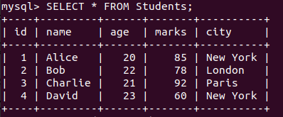

1. **Select specific columns:**

SELECT name, age FROM students;

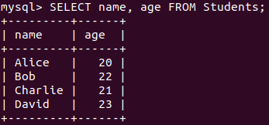

1. **Filter records using WHERE clause:**

SELECT * FROM students WHERE city = 'New York';

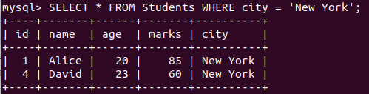

1. **Sort the records by marks (descending):**

SELECT * FROM students ORDER BY marks DESC;

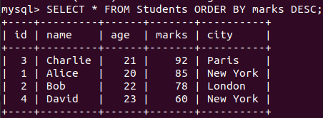

1. **Find students above 21 years of age:**

SELECT * FROM students WHERE age > 21;

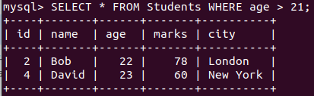

**2. STRING MANIPULATION OPERATIONS**

These are operations performed on **text (string) data** like names, cities, etc.

1. **Convert name to uppercase:**

SELECT UPPER(name) AS Uppercase_Name FROM students;

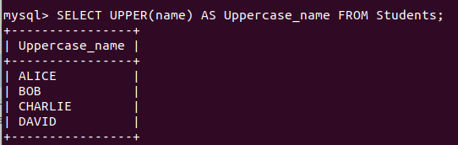

**Get the first 3 letters of each name:**

SELECT LEFT(name, 3) AS Short_Name FROM students;

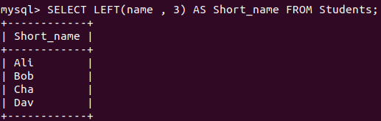

**Concatenate name and city:**

SELECT CONCAT(name, ' from ', city) AS Description FROM students;

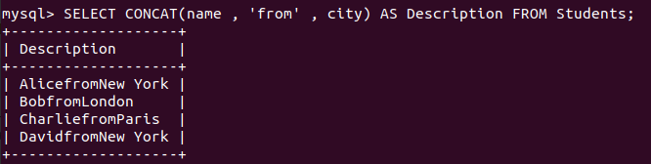

**Replace city name:**

SELECT REPLACE(city, 'New York', 'Mumbai') AS New_City FROM students;

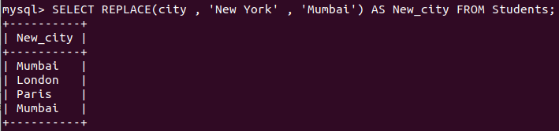

***3. AGGREGATE FUNCTIONS***

Aggregate functions **summarize** the data, such as getting totals, averages, counts, etc.

1. **Count total students:**

SELECT COUNT(*) AS Total_Students FROM students;

**Output:**

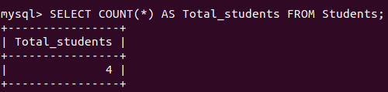

1. **Calculate average marks:**

SELECT AVG(marks) AS Average_Marks FROM students;

**Output:**

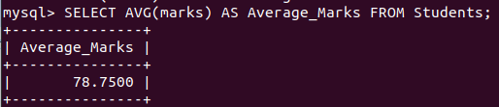

1. **Find the highest marks:**

SELECT MAX(marks) AS Highest_Marks FROM students;

**Output:**

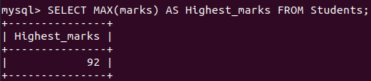

1. **Find the lowest marks:**

SELECT MIN(marks) AS Lowest_Marks FROM students;

**Output:**

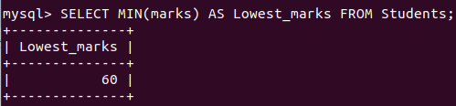

1. **Sum of all marks:**

SELECT SUM(marks) AS Total_Marks FROM students;

**Output:  
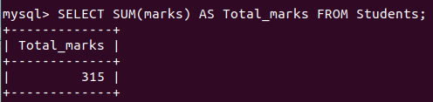**

1. **Group students by city and count them:**

SELECT city, COUNT(*) AS Student_Count FROM students GROUP BY city;

**Output:**

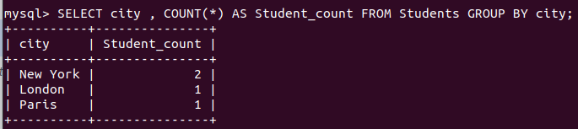

**Combined Query (String + Aggregate)**

Suppose you want to get the highest mark holder's name in uppercase:

SELECT UPPER(name) AS Topper, marks AS Highest_Marks

FROM students

WHERE marks = (SELECT MAX(marks) FROM students);

**Output:**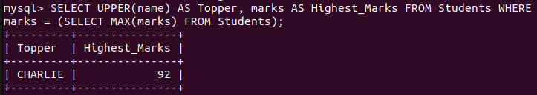

**Conclusion: Hence we have performed Simple queries, string manipulation operations and aggregate functions.**